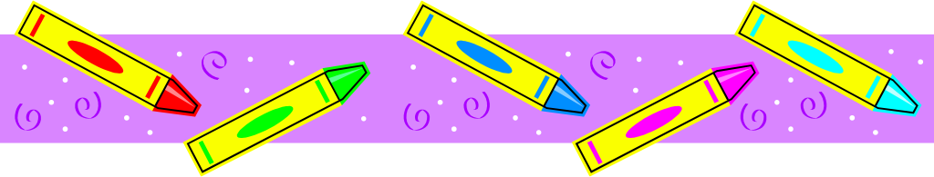
Ms. Conte’s Supply List – September 2024
Thank you in advance for all the supplies. 😊
Grade 1
2 green two pocket plastic folders

Grade 2
2 blue two pocket plastic folders
12-inch ruler with centimeter side

Grade 3
2 red two pocket plastic folders
12-inch ruler with centimeter side

All Grades
1 backpack with no wheels
1 plastic pencil box (8” x 4”) to hold their supplies
1 Refillable water bottle
6 composition marble wide ruled notebooks (no spiral)
1 clipboard (not legal size)
1 box of Kleenex tissues
1 Lysol tub (no Clorox) of disinfecting wipes
1 24 count Crayola crayons
1 scissor
1 pack Ticonderoga #2 pencils
1 pack of erasers
1 headset in a Ziploc bag to be used with laptop
1 pack of post-it sticky notes
2 glue sticks
1 pack of Crayola colored pencils
1 bottle of hand sanitizer

For all new and returning students:
Please have your child create a collage on one composition notebook (back and front) using family photos, pictures from magazines, favorite foods, places, words and pictures. Please use glue. This will be your child’s writing journal.

